**Forbes Billionaire List: SQL Data Exploration**

**(2023)**

**Aman**

**Panjab University**

**75amansharma@gmail.com**

**Q.1) Give a list of top 10 billionaires from USA.**

SELECT name, net_worth, industry

FROM [dbo].[ForbesBillionairesCSV]

WHERE Citizenship='United States'

ORDER BY net_worth DESC

OFFSET 0 ROWS

FETCH NEXT 10 ROWS ONLY;

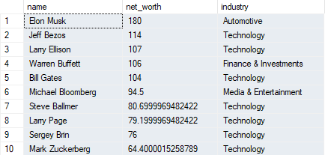

**Conclusion**

We can see that among the top 10 billionaires from USA, 7 out of 10 billionaires have their expertise industry as Technology. This signifies the boom of technology in the 21st century.

**Q.2) Give a list of top 20 billionaires from India and China.**

SELECT name, net_worth, industry AS Industry, Citizenship

FROM [dbo].[ForbesBillionairesCSV]

WHERE Citizenship IN ('India', 'China')

ORDER BY net_worth DESC

OFFSET 0 ROWS

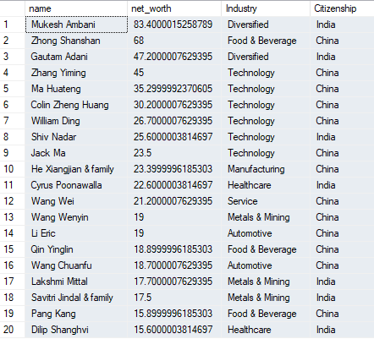FETCH NEXT 20 ROWS ONLY;

**Conclusion**

We can see that among the two countries, Mr. Mukesh Ambani from India is the richest, who controls a number of diversified industries, followed by Zhang Shanshan of China.

**Q.3) Show the top 10 oldest billionaires and their residence.**

SELECT name, age AS Age, Residence, net_worth, industry AS Industry

FROM [dbo].[ForbesBillionairesCSV]

ORDER BY age DESC

OFFSET 0 ROWS

FETCH NEXT 10 ROWS ONLY;

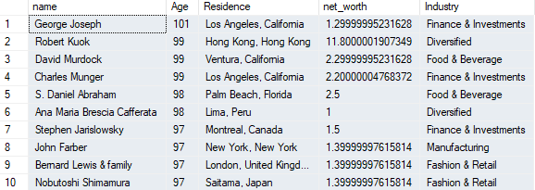

**Conclusion**

The oldest billionaire George Joseph (aged 101) lived in Los Angeles, California with net worth of around 1.3 billon US dollars.

**Q.4) Show the top 10 youngest billionaires and how many of them are single OR married?**

***(For data fix)***

UPDATE [dbo].[ForbesBillionairesCSV]

SET Marital_Status = 'Single'

Where name IN ('Clemente Del Vecchio', 'Kevin David Lehmann', 'Luca Del Vecchio')

SET Marital_Status = 'Married'

Where name IN ('Ben Francis', 'Jonathan Kwok')

***(code)***

SELECT name, age AS Age, Marital_Status, net_worth, industry AS Industry

FROM [dbo].[ForbesBillionairesCSV]

WHERE age IS NOT NULL

ORDER BY age ASC

OFFSET 0 ROWS

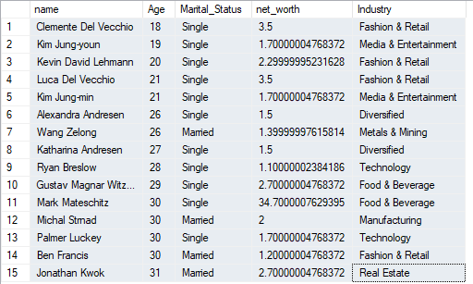FETCH NEXT 15 ROWS ONLY;

***For count:***

SELECT Marital_Status, COUNT(*) AS frequency

FROM (

SELECT name, age AS Age, Marital_Status, net_worth, industry AS Industry

FROM [dbo].[ForbesBillionairesCSV]

WHERE age IS NOT NULL

ORDER BY age ASC

OFFSET 0 ROWS

FETCH NEXT 15 ROWS ONLY) AS SubqueryAlias -- Add an alias for the subquery

GROUP BY Marital_Status;



**Conclusion**

Out of the 15 people on this list, 4 are married while 11 are single. We can see that as we move up in age, we can find a more frequency of married billionaires. The youngest billionaire is Clemente Del Vecchio with a net worth of 3.5 billion dollars. He is single as of now. Jonathan Kwok is aged 31 years old and comes last in this list and is married as of 2023.

**Q.5) How many top 50 billionaires in the world are self-made?**

SELECT name, age AS Age,

CASE

WHEN Self_Made = 1 THEN 'YES'

WHEN Self_Made = 0 THEN 'NO'

ELSE 'UNDEFINED'

END AS Self_Made,

industry AS Industry

FROM [dbo].[ForbesBillionairesCSV]

WHERE age IS NOT NULL

ORDER BY Rank ASC

OFFSET 0 ROWS

FETCH NEXT 50 ROWS ONLY;

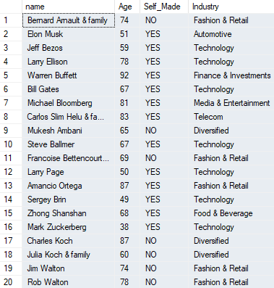

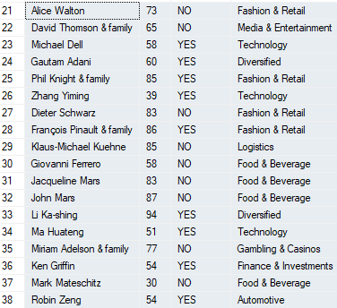

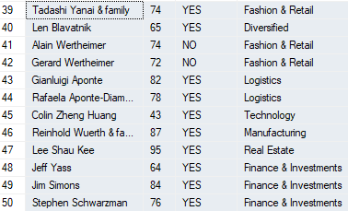

***For count:***

SELECT Self_Made,

COUNT(*) AS Frequency

FROM (

SELECT

CASE

WHEN Self_Made = 1 THEN 'YES'

WHEN Self_Made = 0 THEN 'NO'

ELSE 'UNDEFINED'

END AS Self_Made

FROM [dbo].[ForbesBillionairesCSV]

WHERE age IS NOT NULL

ORDER BY Rank ASC

OFFSET 0 ROWS

FETCH NEXT 50 ROWS ONLY

) AS SubqueryAlias

GROUP BY Self_Made;



**Conclusion**

Out of the 50 billionaires on this list, 18 are not self-made while 32 are self-made. What is meant by self-made is that they built up their businesses from scratch and did not inherit them from their forefathers. Bernard Arnault is the richest man in the world, and is not self-made. The richest self-made billionaire is Elon Musk, who is primarily in the automotive industry.

**Q.6) How many billionaires above age 50 are dropouts.**

SELECT

CASE

WHEN drop_out = 1 THEN 'YES'

WHEN drop_out = 0 THEN 'NO'

ELSE 'UNDEFINED'

END AS drop_out,

COUNT(*) AS Frequency

FROM (

SELECT name, age AS Age, drop_out

FROM [dbo].[ForbesBillionairesCSV]

WHERE age IS NOT NULL AND age > 50

) AS SubqueryAlias

GROUP BY drop_out;

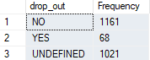

**Conclusion**

We can see that out of the total billionaires above the age of 50, 1161 are not drop outs, that means, they completed their education, while 68 billionaires did not. There is uncertainty in data for 1021 billionaires in this set.

**Q.7) Find all the billionaires from India whose age is equal to the average age of billionaires in the dataset.**

SELECT AVG(age) AS AverageAge

FROM [dbo].[ForbesBillionairesCSV];



SELECT

name,

age,

net_worth,

country

FROM [dbo].[ForbesBillionairesCSV] AS b

WHERE country = 'India' AND age = (

SELECT AVG(age)

FROM [dbo].[ForbesBillionairesCSV]);

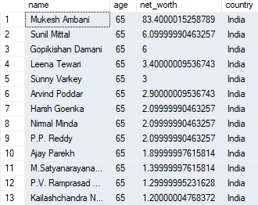

**Conclusion**

We can see that the average age of all the billionaires in the dataset is 65. Hence the richest Indian billionaire aged 65 years is Mukesh Ambani valued at around 84 billion USD, followed by Sunil Mittal. All these 13 Indian Billionaires are 65 years old. Here it is to note that this age data is till 2023, and will differ in future.

**Q.8) What is the most common industry in the dataset.**

SELECT industry,

COUNT(*) AS Frequency

FROM [dbo].[ForbesBillionairesCSV]

GROUP BY industry;

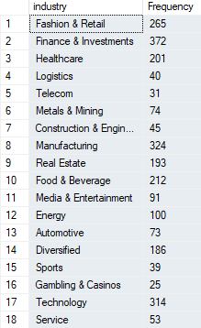

**Conclusion**

The most common industry in the dataset is Finance and Investments, with 372 billionaires in the field, followed by Technology at 314 billionaires. The lowest is Gambling and Casinos at 25.

**Q.9) Give a list of all the billionaires above the age of 70 who attended Harvard University along with their industry.**

SELECT name, Education, age, industry

FROM [dbo].[ForbesBillionairesCSV]

WHERE Education LIKE '%Harvard%'

and age>70 AND NOT drop_out=1;

**Conclusion**

We can see that, among the billionaires in the world, only 36 of them went to Harvard University, and completed a certain level of education there.

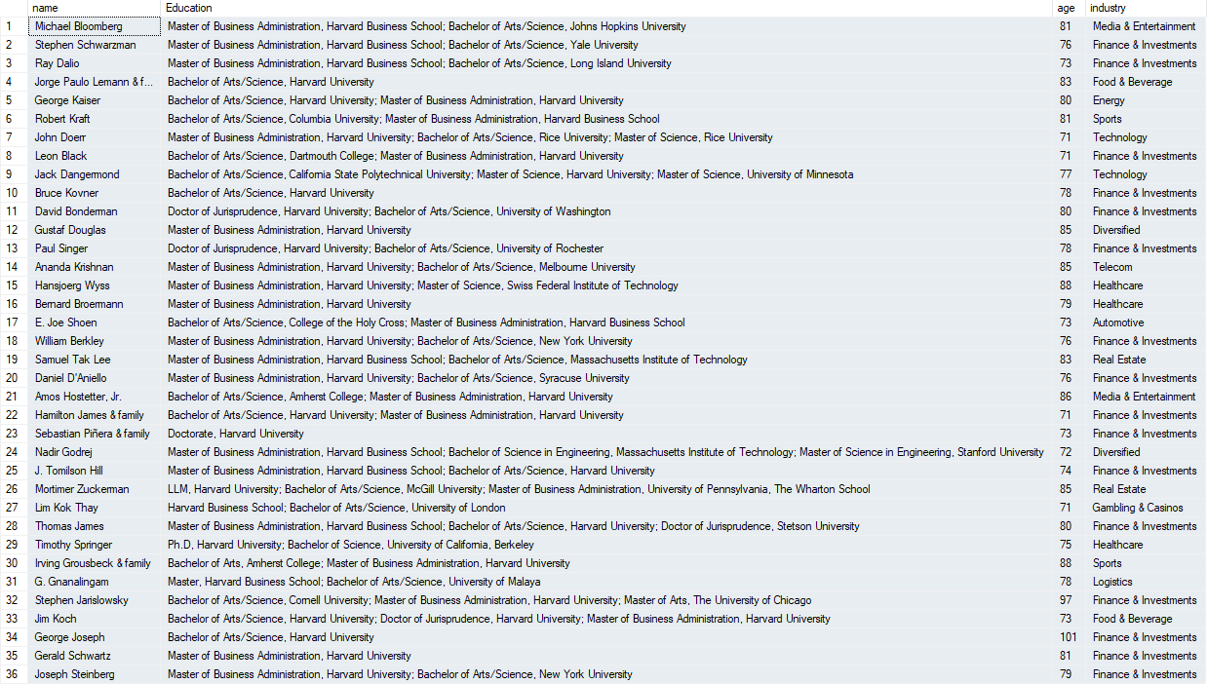

**Q.10) How many billionaires with doctorates are from outside USA.**

SELECT

name,

country,

CASE

WHEN Doctorate = 1 THEN 'YES'

END AS Doctorate

FROM [dbo].[ForbesBillionairesCSV]

WHERE COUNTRY <> 'United States'

AND Doctorate = 1;

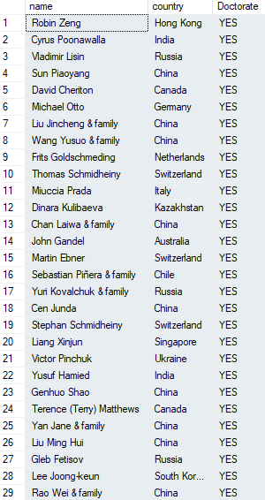

**Conclusion**

Outside the USA, only 29 billionaires from around the world are PHD holders. Some of them include Robin Zeng, Cyrus Poonawalla, Michael Otto, etc.

**Q.11) Give the list of top 20 Billionaires by net worth who live in Florida OR Paris.**

SELECT name, Residence, age, net_worth

FROM [dbo].[ForbesBillionairesCSV]

WHERE Residence LIKE '%Florida%'

OR Residence LIKE '%Paris%'

ORDER BY Rank ASC

OFFSET 0 ROWSFETCH NEXT 20 ROWS ONLY;

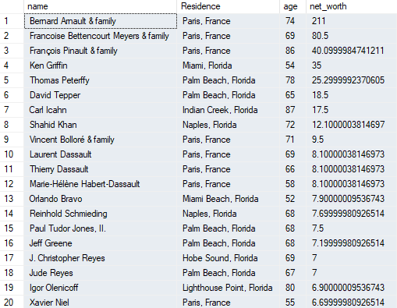

**Conclusion**

Only 20 billionaires live in Florida or Paris, with the worlds richest man, Bernard Arnault, living in Paris, France. Ken Griffin is the richest person living in Florida.

**THANK YOU**